Amazon Sales Report Dashboard

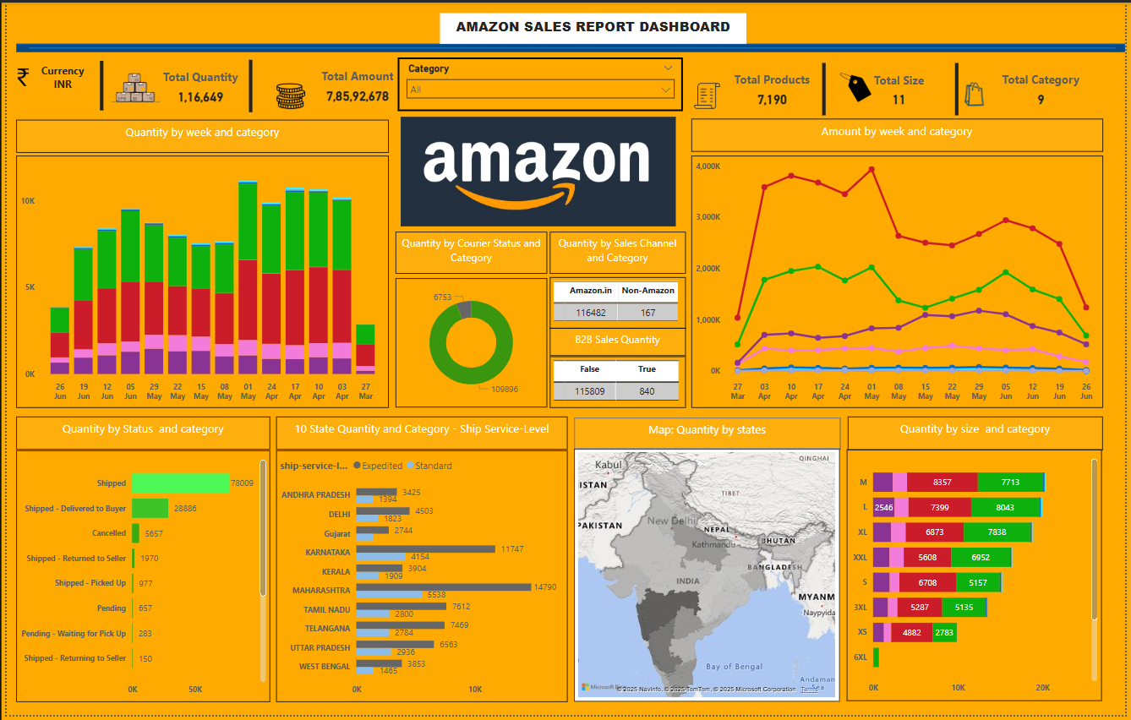

**Insights from the Dashboard**

**Key Performance Indicators (KPIs)**

* **Total Quantity:** 116,649
* **Total Amount:** 78,592,678
* **Total Products:** 7,190
* The company processes **a high volume of orders**, with significant revenue.

**Quantity Trends**

* **Peak sales weeks** occur around late April to early May.
* Sales **fluctuate weekly**, indicating **seasonal trends**.

**Churn by Courier & Status**

* A **large number of orders (109,896)** were successfully delivered.
* **Shipped - Delivered to Buyer:** 28,686
* **Cancelled Orders:** 5,657
  + This indicates a **low churn rate**, but cancellations should be analyzed.

**Geographical Trends**

* **Top-selling states** include **Maharashtra, Karnataka, and Delhi**.
* **Gujarat and Kerala have lower sales**, suggesting potential growth areas.

**Shipping Performance**

* Majority of shipments are **Standard**, with fewer **Expedited**.
* Faster shipping could increase customer satisfaction in high-volume states.

**Sales Channel**

* **Amazon.in dominates sales** with 116,482 orders vs. 167 from non-Amazon sources.
* **B2B sales are very low (840 orders)**, an opportunity for expansion.

**Final Thoughts**

🚀 **Actionable Steps for Business:**

✅ **Focussing on states like Gujarat & Kerala** for marketing efforts.  
✅ **Reducing cancellations** by analyzing reasons (pricing, delivery issues).  
✅ **Improving expedited shipping** to meet demand in key states.  
✅ **Expanding B2B sales** by targeting corporate clients.